POLISHED, PORTFOLIO-READY CASE STUDY REPORT
Bellabeat Case Study Report
By: Oluwakorede Solomon Bamidele
Tools Used: Python, Pandas, Seaborn, Matplotlib
Dataset: Fitbit Fitness Tracker Data (Kaggle)

Executive Summary
Bellabeat is a wellness technology company focused on empowering women through data-driven insights. To support this mission, I analyzed Fitbit activity, sleep, and intensity data from 30 users to uncover behavioural patterns and identify opportunities for Bellabeat to enhance user engagement.
Two clear trends emerged from the analysis:
- Users spend most of their day sedentary, with very low levels of moderate or vigorous activity.
- Daily steps strongly correlate with calories burned, confirming that walking is the most accessible and impactful behaviour for improving daily energy expenditure.
Based on these findings, I recommend that Bellabeat introduce active-break reminders to reduce prolonged inactivity and promote step-based challenges to encourage consistent movement. These features can help users build healthier routines while increasing engagement with the Bellabeat app and ecosystem.

Introduction
Bellabeat designs smart wellness products for women, including wearables and a mobile app that tracks activity, sleep, and stress. To support data-driven product development, I analyzed Fitbit data from 30 users to understand daily behaviour patterns and identify opportunities for Bellabeat to enhance user engagement.
This analysis focuses on activity levels, sedentary behaviour, sleep patterns, and calorie expenditure.

Data Preparation
Using Python (pandas, seaborn, matplotlib), I performed the following steps to prepare the dataset for analysis :
- Loaded daily, hourly, minute-level, sleep, and weight datasets
- Cleaned column names and removed duplicates
- Converted all timestamps to datetime format
- Aggregated minute-level sleep into daily totals
- Merged sleep and activity data into a unified dataset
- Filtered out noise (e.g., days with 0 steps or 1440 sedentary minutes)
This process produced a clean, analysis-ready dataset suitable for generating insights.

Key Findings
1. Users are highly sedentary
Across the dataset, users spent 10–14 hours per day sedentary, with very few minutes of moderate or vigorous activity. This pattern appeared consistently in:
- Sedentary minutes distribution
- Activity intensity breakdown
- Correlation heatmap (negative correlation between sedentary and active minutes)
Interpretation:
Users need support breaking long periods of inactivity.

2. Steps strongly influence calories burned
Regression plots and correlation analysis showed a strong positive relationship between:
- Total steps
- Very active minutes
- Calories burned
Interpretation:
Walking is the most effective and accessible behaviour for increasing daily energy expenditure.

Recommendations
Recommendation 1: Introduce Active-Break Reminders
Bellabeat should implement or enhance features that:
- Prompt users to stand, stretch, or walk briefly
- Detect long sedentary periods and send gentle nudges
- Reward users for breaking inactivity streaks
Expected impact:
Improves daily movement, reduces sedentary behaviour, and increases app engagement.

Recommendation 2: Promote Step-Based Challenges
Bellabeat can encourage consistent movement by offering:
- Daily and weekly step goals
- Community step challenges
- Personalized step targets
- Motivational notifications on low-step days
Expected impact:
Boosts user motivation, increases daily activity, and supports long-term habit formation.

Conclusion
The Fitbit dataset reveals clear opportunities for Bellabeat to support healthier routines through targeted behavioural nudges. By focusing on reducing sedentary time and promoting step-based activity, Bellabeat can enhance user wellness while strengthening engagement with its app and product ecosystem.

🌟 Visual Captions (for your charts)
Use these under each chart in your portfolio or presentation:

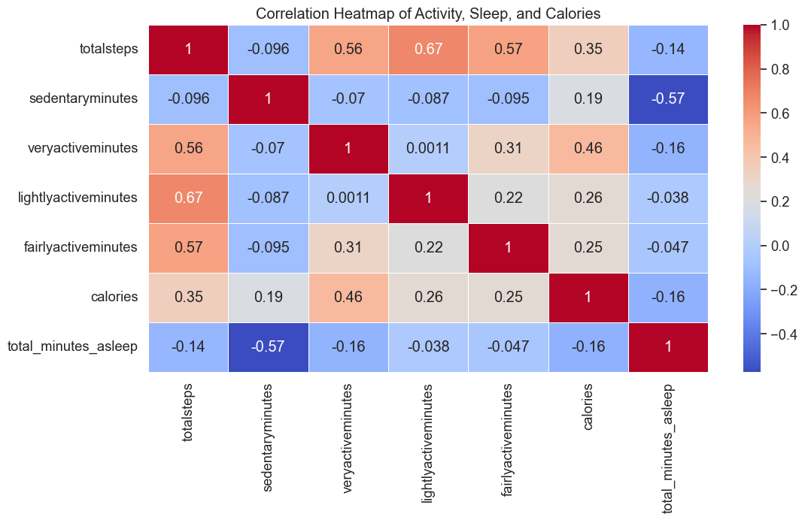
- Correlation Heatmap:
“Steps, active minutes, and calories show strong positive relationships, while sedentary time is negatively associated with activity.”

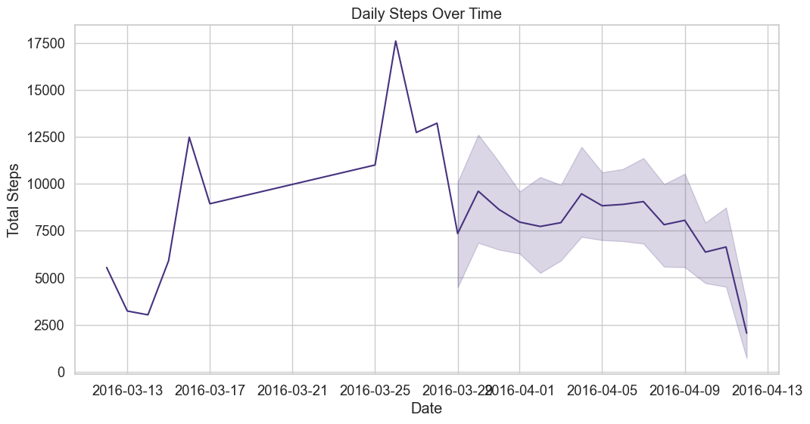
- Daily Steps Over Time:
“User activity fluctuates significantly, revealing inconsistent movement patterns.”
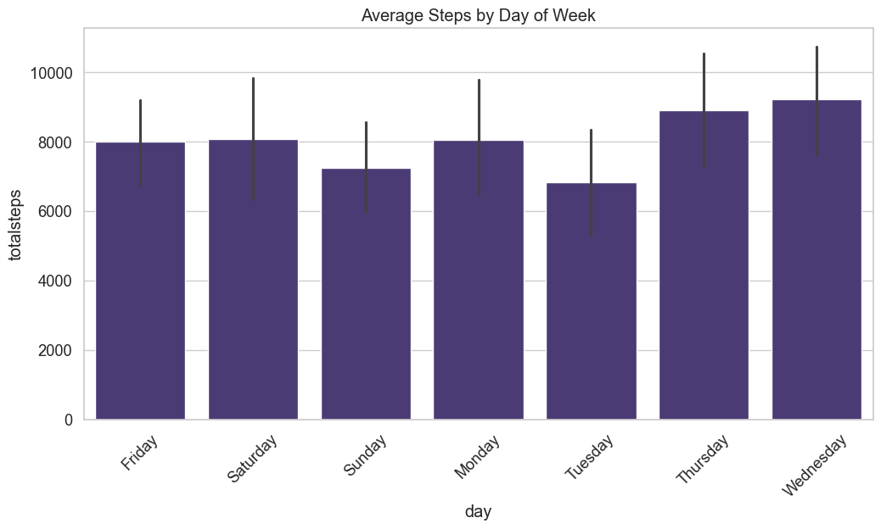
- Steps by Day of Week:
“Certain days show consistently lower step counts, suggesting opportunities for targeted motivation.”
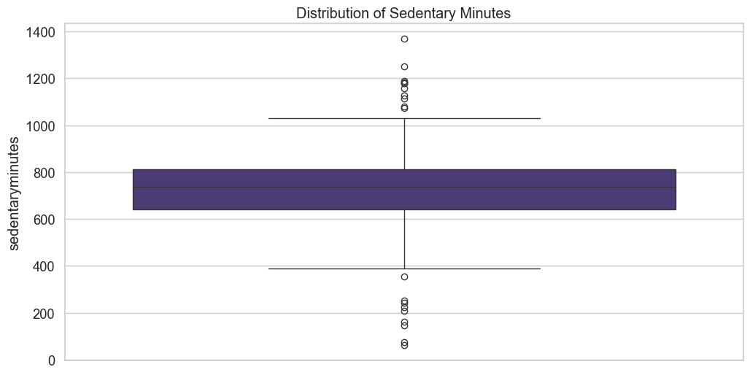
- Sedentary Minutes Distribution:
“Most users spend 10–14 hours sedentary per day, indicating prolonged inactivity.”
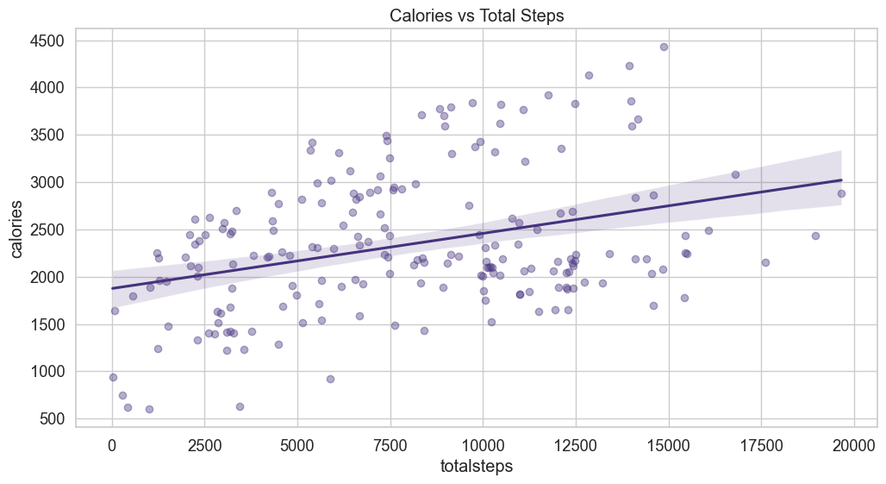
- Calories vs Steps:
“Higher step counts are strongly associated with increased calorie burn.”

